Yuriy Kitsis
4 Gardenia Court,
Toronto, Ontario, M2M 4G2
Phone: (416) 512-8713 Cell: (416) 992-2987
E-mail: ykitsis@rogers.com
WWW: http://www.kitsis.org/

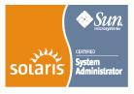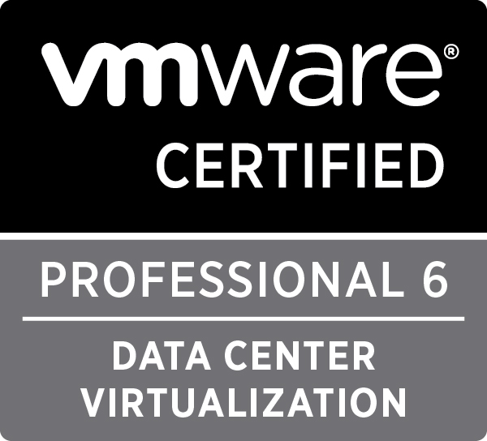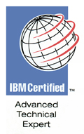

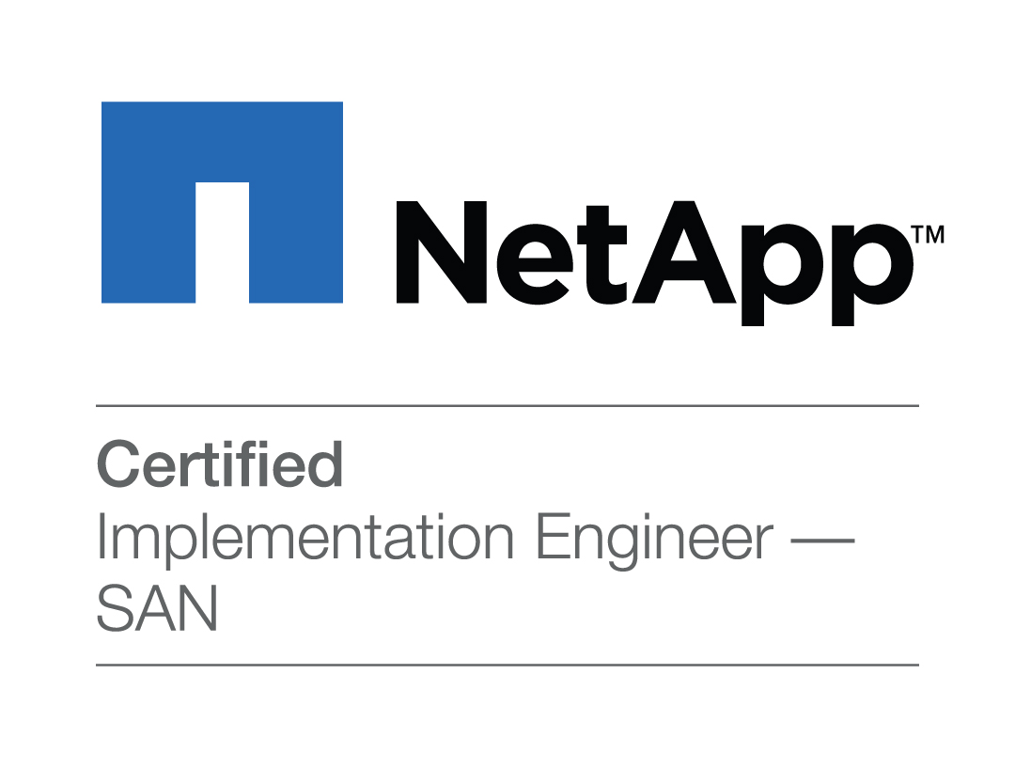

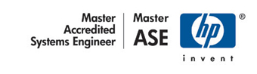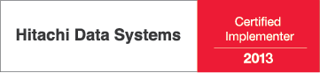

OBJECTIVE
Senior Enterprise Systems/SAN/Enterprise Storage/Virtualization consultant.

SUMMARY OF QUALIFICATION
An Enterprise Systems Consultant with over 20 years of experience planning, designing, installing, configuring, auditing, and administering UNIX/Windows-based systems, clusters, SANs and Enterprise Storage Solutions. Strong expertise in Enterprise Data protection projects, disaster recovery, data migration, database technology and Servers/Storage virtualization.

CERTIFICATION AND PROFESSIONAL RECOGNITION
IBM | IBM Certified Advanced Technical Expert - Power Systems with AIX v3  IBM Certified Deployment Professional - Tivoli Storage Manager V5.4  IBM Certified Specialist - Storage Networking Solutions V4

HP | HP Master Accredited Solution Expert (MASE) - Storage Solutions Architect  Certified Systems Engineer (CSE) - Specialty in High Availability HP-UX 11i v3  Accredited Systems Engineer (ASE) - HP ProLiant ML/DL/SL Servers [2010]  Accredited Systems Engineer (ASE) - HP BladeSystem Solutions [2010]  Accredited Presales Consultant (APC) - HP Enterprise Storage

Oracle | Oracle Database 11g Administrator Certified Professional  Oracle Database 10g Administrator Certified Professional  Oracle Enterprise Linux Administrator Certified Associate

EMC | EMC Isilon Certified Integration Engineer

Cisco | Cisco Data Center Storage Networking Design Specialist  Cisco Unified Computing Technology Design Specialist

Sun Microsystems | Sun certified system administrator for Solaris 10  Sun certified network administrator for Solaris 10  Sun certified system administrator for Solaris 9  Sun certified network administrator for Solaris 9

VMware, VCP ID 137 | Vmware Certified professional vSphere6  Vmware Certified professional vSphere5  Vmware Certified professional vSphere4  Vmware Certified professional VI3  Vmware Certified professional ESX2.x

Network Appliance | NetApp Certified Implementation Engineer (NCIE) SAN & Virtualization  NetApp Certified Data Management Administrator (NCDA)

RedHat Enterprise Linux | RedHat Certified Engineer on RedHat Enterprise Linux v5  RHCE Certificate number 805007387826084  RedHat Certified Engineer on RedHat Enterprise Linux v3  RHCE Certificate number 803004513309901

Brocade | Brocade Certified Fabric Professional  Brocade Certified SAN Designer

Hitachi Data Systems | Hitachi Data Systems Qualified Professional - Modular storage installation  Hitachi Data Systems Qualified Professional - NAS installation  Hitachi Data Systems Certified Implementer - Enterprise  Hitachi Data Systems Certified Implementer - Modular

Symantec | Symantec Technical Specialist. Veritas Storage Foundation 5.1 for Windows  Symantec Technical Specialist. Veritas Cluster Server 5 for Windows

Microsoft  MCP 375267 | Microsoft Certified Solutions Expert: Server Infrastructure

AREAS OF EXPERTISE
- Over twenty years of experience in installations, programming, analyzing and troubleshooting; strong problem solving; team leadership.
- Implementation of UNIX (AIX, HP-UX, Solaris, LINUX) and Windows systems upgrades, migrations, improvements, tuning.
- Proficient in designing configuring Enterprise SAN infrastructure utilizing multi-vendor equipment. (Brocade, CISCO, Qlogic, McData, etc.)
- All aspects of IBM AIX, HP-UX, SUN Solaris, LINUX and Windows Capacity Planning, Performance Tuning, Systems management and automation.
- Oracle Server and tools; installation and upgrades; backup and recovery; database creation and replication; monitoring database activity and setting performance metrics; Oracle capacity planning and storage requirements, database statistics and reports; Configure and tune Oracle system parameters and SQL scripts; data model design and maintenance.
- Enterprise virtualization techniques; design, planning and implementation of Logical partitions, various virtual machines, and P2V (physical to virtual) migrations.
- Design/architecture/evaluation of software and hardware solutions.
- High availability solutions design, planning and implementation (IBM HACMP; LINUX, HP MC/ServiceGuard; Microsoft cluster; Veritas Cluster; SUN Cluster).
- Disaster Recovery management; backup strategy and testing
- Advanced Shell and C programming.
- Network security. Strategy development and implementations.
- Experienced in telephone customer support.

WORKING KNOWLEDGE OF COMPUTER PRODUCTS
- HA Clustering SW: Veritas Cluster Server, Microsoft Cluster, HP MC/ServiceGuard, IBM HACMP; SUN Cluster, Oracle Real Application Cluster (RAC); LINUX clustering technologies.
- Volume Management (LVM): Veritas Volume Manager, HP-UX LVM, AIX LVM; LINUX LVM.
- Performance Tuning: Solaris, HP-UX, AIX, LINUX, Windows NT, 2000, 2003, 2008, 2012
- Operating Systems: HP-UX 9, 10, 11i, Solaris 2.5, 2.6, 7, 8, 9, 10; AIX 4.x, 5L; 6.x, 7.x; Windows NT, 2000, 2003, 2008, 2012, XP, Vista, Windows 7, Windows 8; various LINUX “flavours” (Red Hat, SUSE, UBUNTU, etc.)
- Virtualization: VMware ESX server 2.x, Virtual Infrastructure 3.x; vSphere 4; vSphere 5; vSphere 6; XEN; KVM.
- Server HW: HP9000, SUN SunFire series, IBM P-series, IBM x-series, HP Proliant, CISCO UCS B-series and C-series.
- Monitoring Frameworks: HP Openview (ITO, OVO, Measureware, PerfView, Network Node Manager), IBM NetView.
- Database: Oracle 8, 8i, 9i, 9i RAC, 10g, 10g RAC, 11g, 11g RAC, IBM UDB/DB2
- Storage HW: EMC Clariion, Symmetrix, DMX, VNX; HDS Lightning (92xx, 95xx, 99xx), AMS/WMS/USP/USP-V/USP-VM/HUS/HUS-VM; HP XP, EVA, 3PAR; SUN StorEdge, NetApp Filers.
- Backup SW: Veritas Netbackup 3.4, 4.5, 5, 6, 7.x, Legato Networker, Oracle RMAN, HP OmniBack, Tivoli Storage Manager.
- SAN Switches: Brocade, Cisco MDS series, McData, Qlogic
- Storage SW: EMC ESN Manager, Timefinder, SRDF, Volume Logix, Config Manager, Powerpath; HDS True Copy, ShadowImage, Universal Volume Replicator, HDLM, HiCommand suite; HP Storage Management, Secure Path.
- Security: SSH, SSL, IPchains, IPtables, TCP Wrappers, Tripwire, port scanners, password crackers
- Messaging: MS-Exchange 5.5, 2000, 2003, 2007, 2010, 2013.
- Programming: Korn shell, Awk, Sed, Perl, C.

EMPLOYMENT HISTORY
Flexity Solutions
Richmond Hill, Ontario
06/2005 – present Senior Consultant
Infostream Technologies
Richmond Hill, Ontario
03/2001 – 05/2005 Enterprise Storage Senior Consultant
- Enterprise Storage. Leading numerous SAN engagements using a variety of operating systems (SUN, AIX, HP-UX, Windows, LINUX)
- Perform High-Availability engagements to implement Veritas Foundation Suite, VCS, VVR, Database Edition, creation of Custom Agents for VCS, SAN Point Foundation Suite, and SAN Point Control.
- Oracle9i RAC implementations on HP-UX, AIX and LINUX in stretched cluster configuration.
- Enterprise Backup solutions. Development of Backup/Restore, Disaster Recovery Policies and Procedures for large corporate environments.
- Managing new systems migrations, upgrade installations and system rollouts within time and budget constraints.
- Designed and configured Windows 2000 Cluster network in an active/active and active/passive configuration of MS-Exchange 2000.
- Designed, configured, and implemented an enterprise custom JumpStart server infrastructure supporting Solaris 2.6, 7, 8, and 9.
- Preventative maintenance, proactive system administration, performance tuning.
- Oracle9i RAC implementations on HP-UX, AIX and LINUX in stretched cluster configuration.
Nortel Networks
Brampton, Ontario
08/2000 – 03/2001 Capacity Planning and Performance consultant
- Performance analysis, reporting, and problem determination for mixed UNIX environments.
- Evaluation, recommendation and implementation of next generation technologies.
- Plan UNIX capacity, architecture and manage performance to assure efficient utilization of corporate computing assets.
- Proactive utilization monitoring of production environment.
- Provide recommendations on global and specific performance issues in various UNIX environments.

GE Capital Information Technology Solutions
Mississauga, Ontario
02/1997 – 07/2000 Enterprise System Integration Specialist
- System infrastructure design for various UNIX implementations (AIX, HP-UX, Sun Solaris).
- Enterprise Storage Subsystems planning and implementation (HP XP256, EMC, IBM ESS, Compaq ESA12000).
- Development of Production environment for conversion from legacy mainframe to RS/6000 SP2 environment consisting of Developing Testing procedures, Operational testing, Acceptance testing, Disaster/Recovery, Security and Performance tuning.
- Development of Backup/Restore, Disaster Recovery Policies and Procedures for large corporate environments.
- Oracle and DB2/UDB capacity planning and storage requirements.
- Configure and tune Oracle system parameters and SQL scripts.
- Planning, Installation and setup of HP MC/ServiceGuard high availability solution with large Oracle databases and HP XP storage arrays.
- HACMP solution development for RS/6000 SP2 nodes and standalone RS/6000 machines.
- Development of Security Policy and Procedures for UNIX. Implementation of Axent Technologies Omniguard Enterprise Security Manager and Intruder Alert, implementation of corporate Information Security Standards.
- Software distribution strategy for corporate clients (Network Installation Manager for AIX, HP-UX Software distribution).
- Virtual Private Networks.
- Assessing various SP2, AIX, HP-UX, and Solaris requirements hardware/software.
- System management and support in heterogeneous environment.
- Performance monitoring, system tuning and capacity planning.
- Writing operation procedures and training the operators.

Vision Technologies Integrated CAD/CAM Systems Inc.
Vaugan, Ontario
06/1995 - 02/1997 System Administrator.
Odessa State Low - Temperature Academy
08/1992 - 07/1994 Mechanical Engineer of Research Sector of CAD/CAM department
STROYGIDROPRIVOD National Design and Technology Institute
04/1985 – 06/1985 Technician-Mechanic of prototype production department.

EDUCATION
1987-1992 | Master of Science in Engineering Engineer-Programmer.

REFERENCES
Available upon request.

